package PageObjects;  
  
import org.openqa.selenium.By;  
import org.openqa.selenium.WebDriver;  
import org.openqa.selenium.WebElement;  
  
public class LoginPage {  
  
 //we have to create page library here. it is nothing related to your test  
 //this page clas, we have to write under src-main-java.  
  
 private WebDriver driver;  
  
  
 // By Locators  
 private By usernameInputLocator = By.*name*("username");  
 private By passwordInputLocator = By.*name*("password");  
 private By loginButtonLocator = By.*xpath*("//button[@type='submit']");  
 private By forgotYourPasswordLocator = By.*className*("//p[@class='oxd-text oxd-text--p orangehrm-login-forgot-header']");  
 private By dropDownMenuLocator = By.*cssSelector*(".oxd-icon.bi-caret-down-fill.oxd-userdropdown-icon");  
 private By logoutTextLocator = By.*xpath*("//a[normalize-space()='Logout']");  
  
 // CONSTRUCTOR  
 // this constructor says that whenever you try to create the object  
 // of login page, give me the driver and the same driver will be given  
 // to the login page type that is declared with private keyword so that  
 //we cannot access the driver out of this particular class.  
 public LoginPage(WebDriver driver){  
 this.driver = driver;  
  
 }  
  
 // Page Methods/Actions  
  
 //page object is a classic example of encapsulation. you can see that private  
 //By locators can be accessed by the public page actions over here  
  
 public void enterUsername(String username){  
 WebElement usernameInput = driver.findElement(usernameInputLocator);  
 usernameInput.sendKeys(username);  
  
 }  
 public void enterPassword(String password){  
 WebElement passwordInput = driver.findElement(passwordInputLocator);  
 passwordInput.sendKeys(password);  
 }  
 public void clickLoginButton(){  
 WebElement loginButton = driver.findElement(loginButtonLocator);  
 loginButton.click();  
  
 }  
 public void clickForgotYourPassword(){  
 WebElement forgotYourPassword = driver.findElement(forgotYourPasswordLocator);  
 forgotYourPassword.click();  
 }  
 public void clickDropDownMenu(){  
 WebElement dropDownMenu = driver.findElement(dropDownMenuLocator);  
 dropDownMenu.click();  
 }  
 public boolean checkForgotYourPwdLink(){  
 return driver.findElement(forgotYourPasswordLocator).isDisplayed();  
 }  
 public boolean checkLogoutText(){  
 return driver.findElement(logoutTextLocator).isDisplayed();  
 }  
 public void login(String username, String password){  
 enterUsername(username);  
 enterPassword(password);  
 clickLoginButton();  
 }  
 public String getForgotYourPwdPageUrl(){  
 String forgotYourPwdPageUrl = driver.getCurrentUrl();  
 return forgotYourPwdPageUrl;  
 }  
}

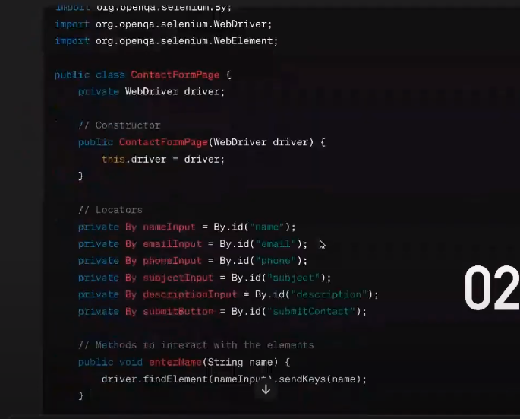

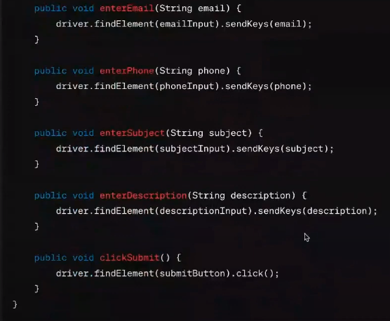 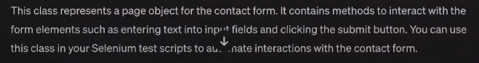

LOGIN.FEATURE FILE

Feature:Login functionality for Orangehrm website  
 As a registered user in Orangehrm website  
 I want to login into the website  
 So that I can access my account-related features and mange my orders  
  
 Background:  
 Given I am on the Orangehrm login page  
  
  
 Scenario: Successful login with valid credentials  
 When I enter the valid username **"Admin"** and the password **"admin123"** And I click the login button  
 Then I should be logged in successfully  
  
 Scenario Outline: Unsuccessful login with invalid credentials  
 Given I have entered invalid **"<username>"** and **"<password>"** When I click on the login button  
 Then I should see an **"<error message>"** indicating invalid credentials  
  
  
 Examples:  
 | **username** | **password** | **error message** |  
 | **admim** | **admin345** | **invalid credentials**|  
 | **admins** | **admind1** | **invalid credentials**|  
  
  
 Scenario: Navigating to the forgotten password page  
 When I click on the **"Forgotten Password"** link  
 Then I should be redirected to the password page

LOGIN STEP DEF

package StepDefinitions;  
  
import PageObjects.LoginPage;  
import io.cucumber.java.After;  
import io.cucumber.java.Before;  
import io.cucumber.java.en.*;  
import org.openqa.selenium.By;  
import org.openqa.selenium.WebDriver;  
import org.openqa.selenium.chrome.ChromeDriver;  
import org.openqa.selenium.firefox.FirefoxDriver;  
import org.testng.Assert;  
  
public class LoginPageStepDef {  
  
 private WebDriver driver;  
 private LoginPage loginPage;  
  
 /* @Before  
 public void setup(){  
 driver = new ChromeDriver();  
  
 }  
 @After  
 public void tearDown(){  
 if (driver!=null){  
 driver.quit();  
 }  
  
  
 }*/  
  
 @Given("I am on the Orangehrm login page")  
 public void i_am_on_the_orangehrm_login_page() {  
 driver = new ChromeDriver();  
 driver.manage().window().maximize();  
 driver.get("https://opensource-demo.orangehrmlive.com/web/index.php/auth/login");  
  
  
 loginPage = new LoginPage(driver);  
  
 }  
  
 @When("I enter the valid username {string} and the password {string}")  
 public void i_enter_the_valid_username_and_the_password(String string, String string2) {  
 loginPage.enterUsername("admin");  
 loginPage.enterPassword("admin123");  
  
 }  
  
 @And("I click the login button")  
 public void i_click_the_login_button() {  
 loginPage.clickLoginButton();  
  
  
 }  
  
 @Then("I should be logged in successfully")  
 public void i_should_be_logged_in_successfully() {  
 Assert.*assertEquals*(loginPage.checkLogoutText(), true);  
  
 }  
  
 @Given("I have entered invalid {string} and {string}")  
 public void i_have_entered_invalid_and(String username, String password) {  
 loginPage.enterUsername(username);  
 loginPage.enterPassword(password);  
 }  
  
 @When("I click on the login button")  
 public void i_click_on_the_login_button() {  
 loginPage.clickLoginButton();  
  
 }  
  
 @Then("I should see an {string} indicating invalid credentials")  
 public void i_should_see_an_indicating_invalid_credentials(String errormessage) {  
 Assert.*assertEquals*(driver.findElement(By.*cssSelector*(".oxd-text.oxd-text--p.oxd-alert-content-text")).isDisplayed(), true);  
  
 }  
  
 @When("I click on the {string} link")  
 public void i_click_on_the_link(String forgottenpassword) {  
 loginPage.checkForgotYourPwdLink();  
  
  
 }  
  
 @Then("I should be redirected to the password page")  
 public void i_should_be_redirected_to_the_password_page() {  
  
 Assert.*assertTrue*(loginPage.getForgotYourPwdPageUrl().contains("requestPasswordResetCode"));  
  
  
 }  
  
  
}

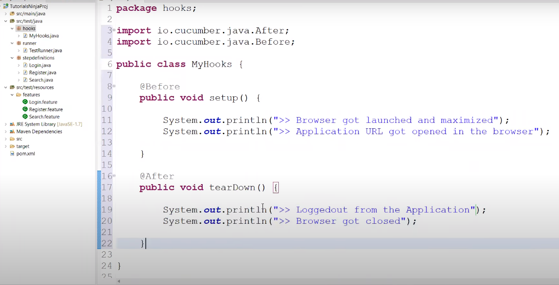 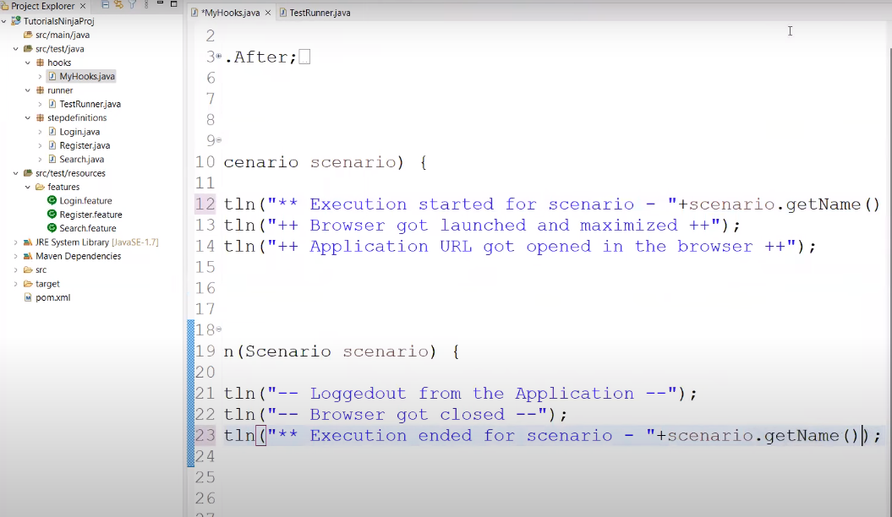 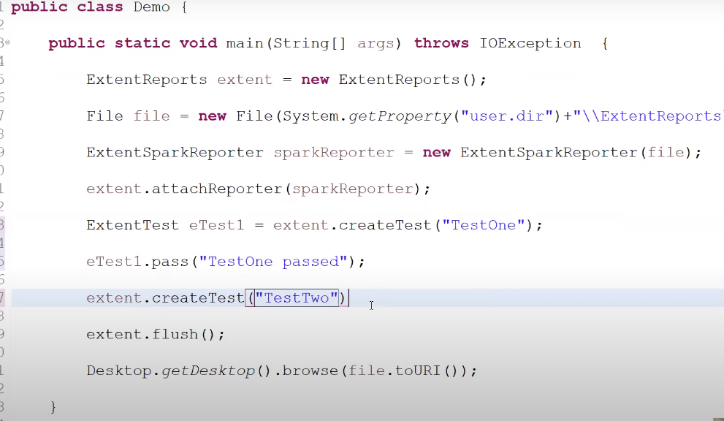 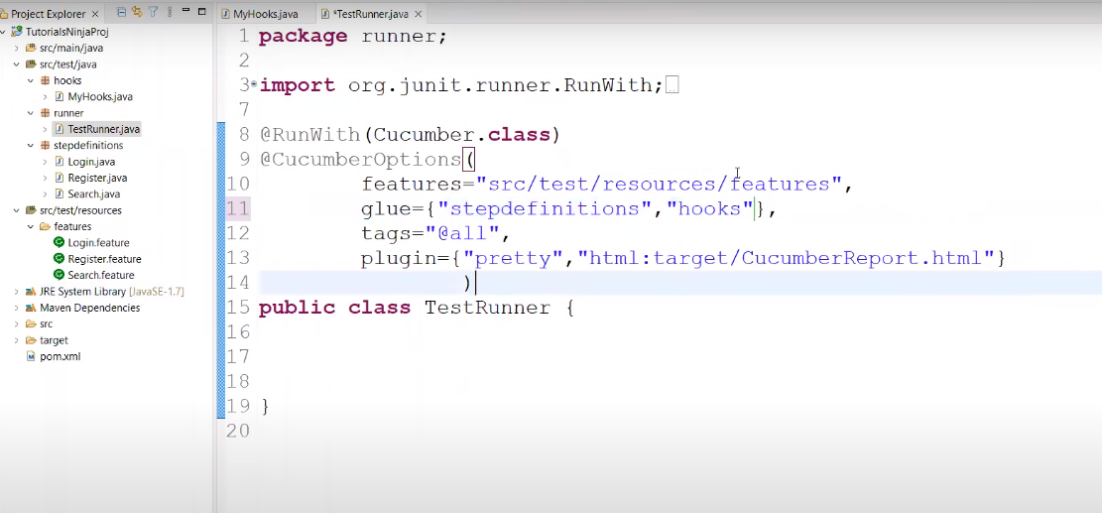

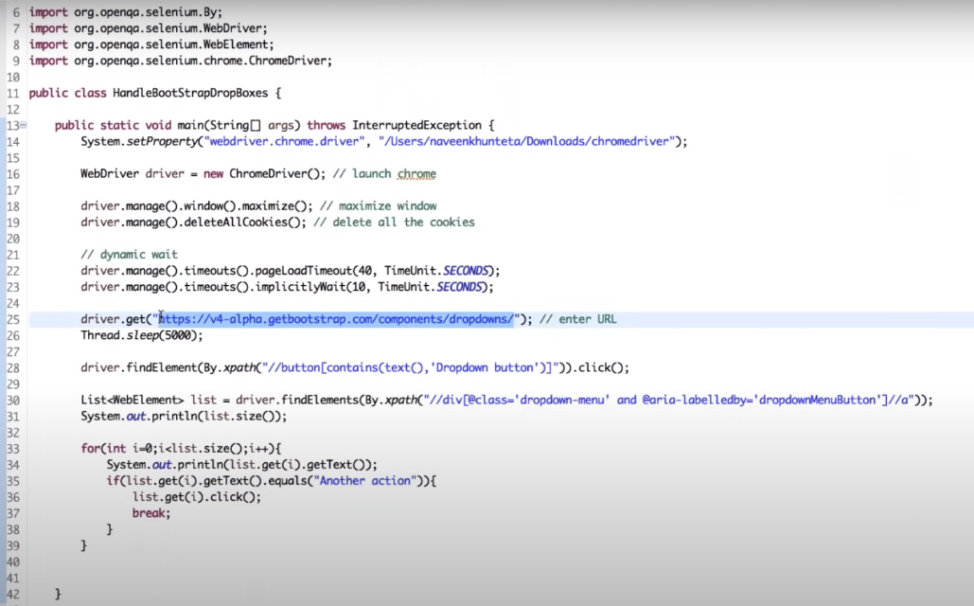

HOW TO BECOME GENIUS IN XPATH IN SELENIUM

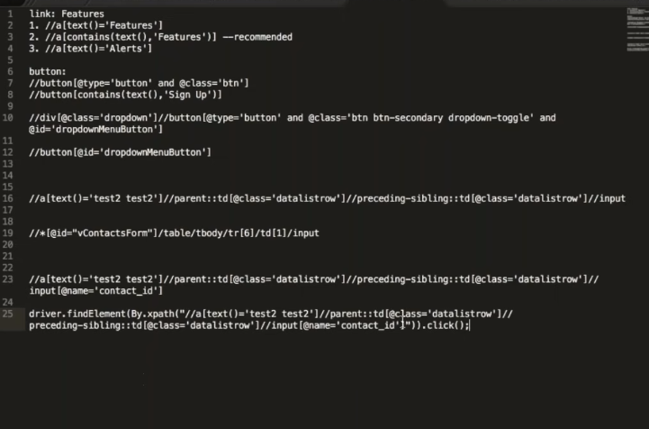 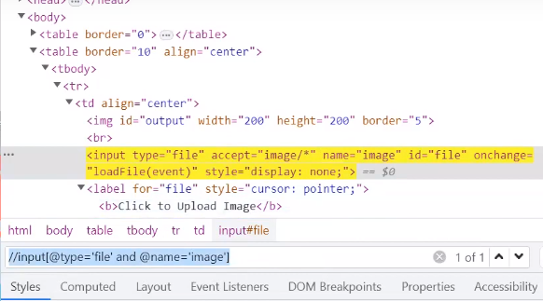

HOW TO AUTOMATE IMAGE UPLOAD IN SELENIUM AUTOMATION

Whatever is the path of the file which you want to upload through the automation, just create the

Variable and just paste the path by going to the location of the path then copy the name of the file

And place in the variable like the example below

The condition is that, in your web page in your web, this upload functionality should be implemented by the double forward slashes input at the rate(@) type equal symbol single quote open file single quote close ------ //input[@type=’file’ and @nsme=’image’]

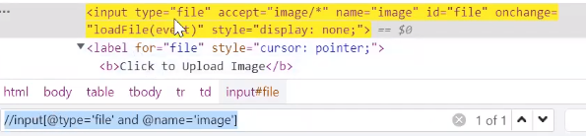

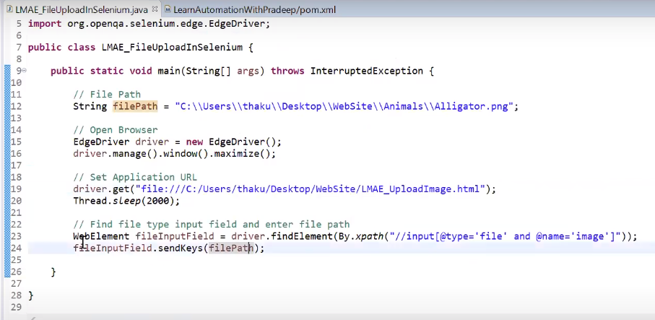 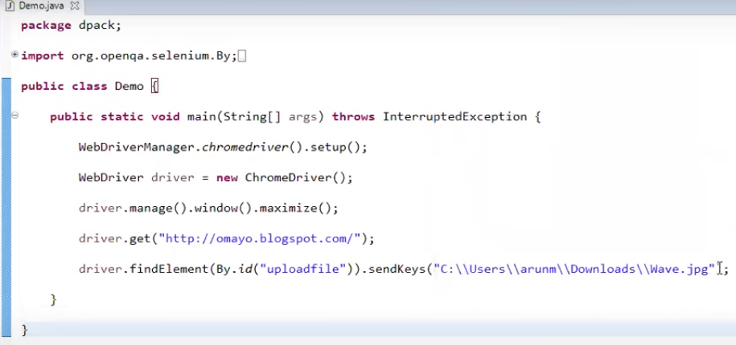 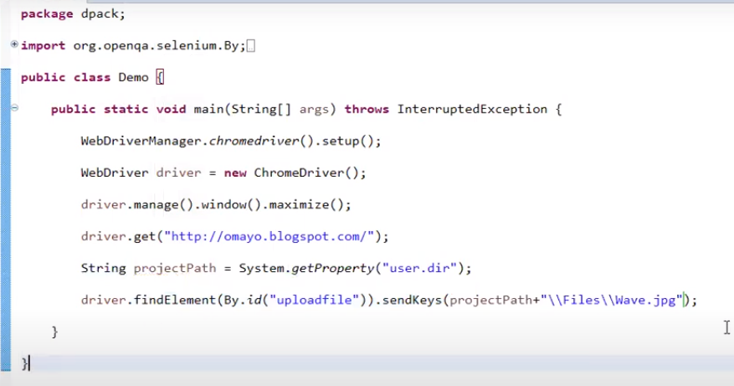

================================================================================

**Selenium + BDD Cucumber + Java + Web Driver manager + Allure reporting + Page Object Model**

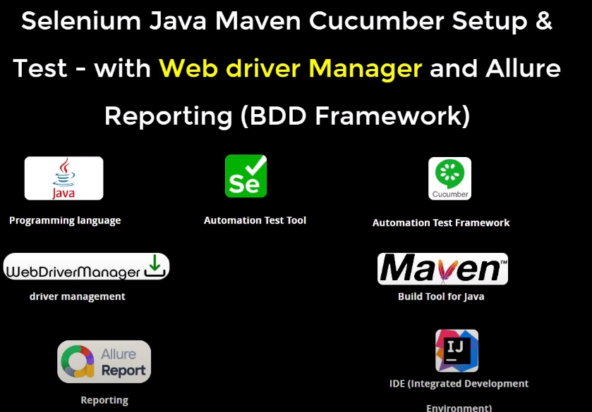

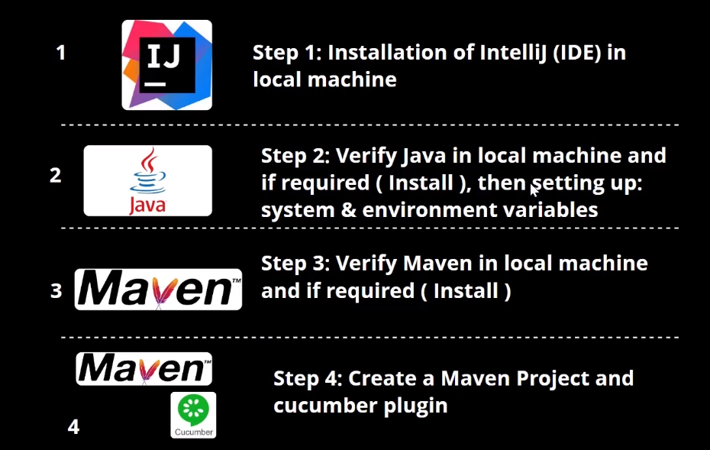 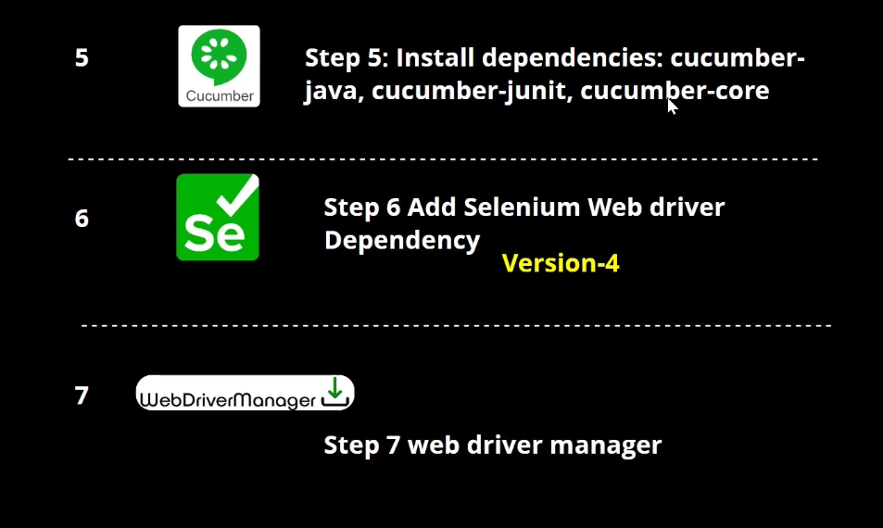 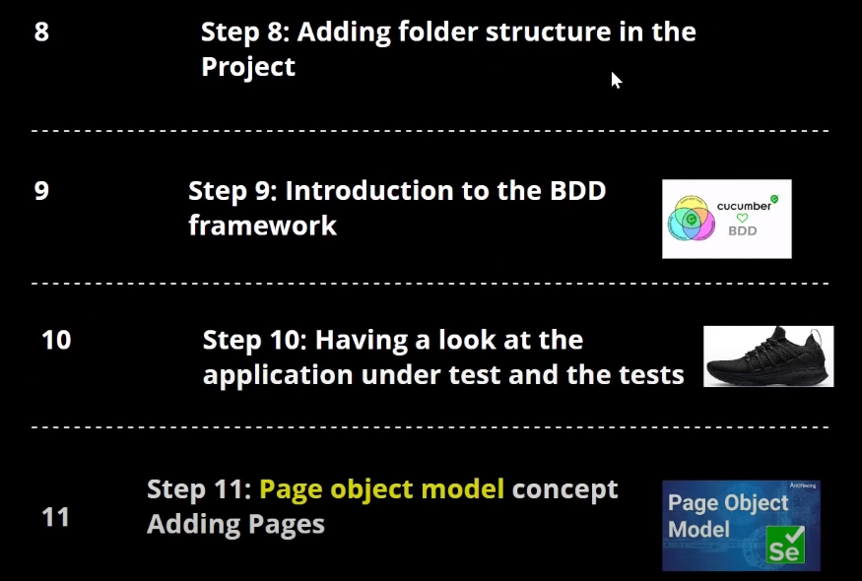 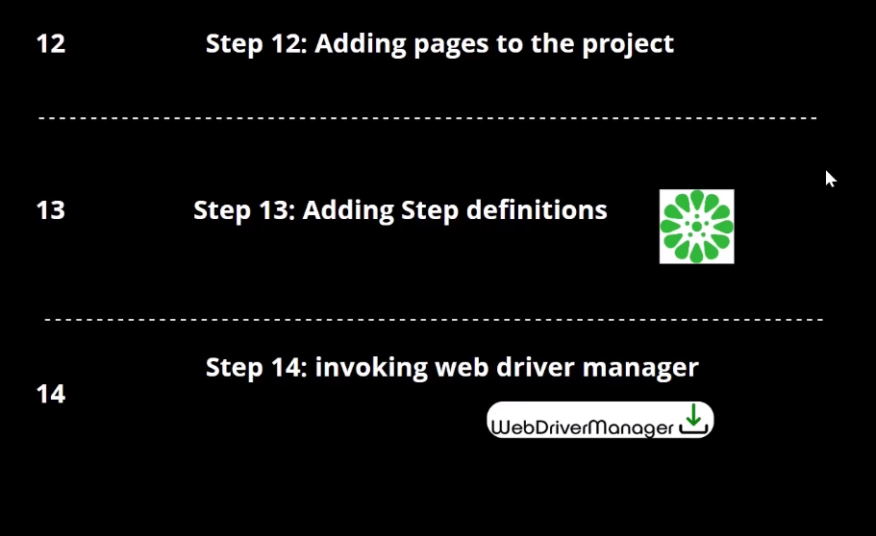 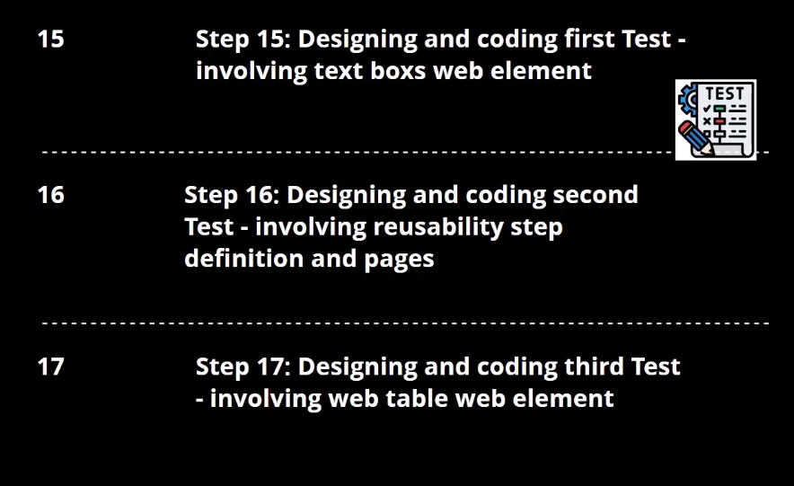 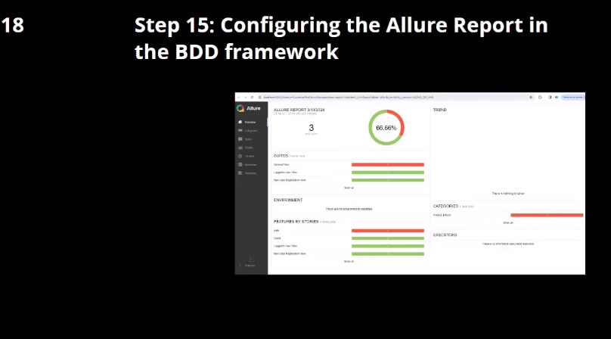 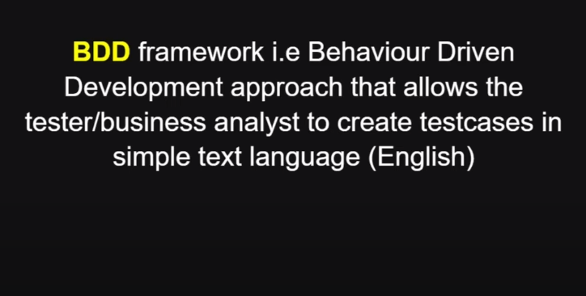 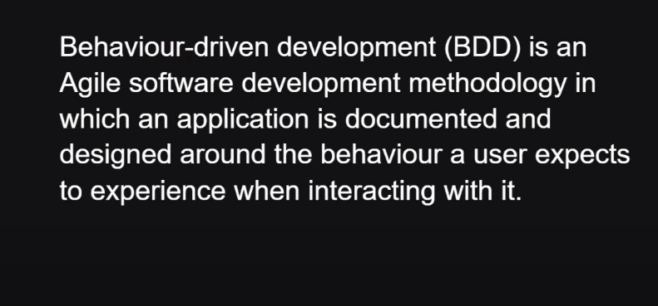 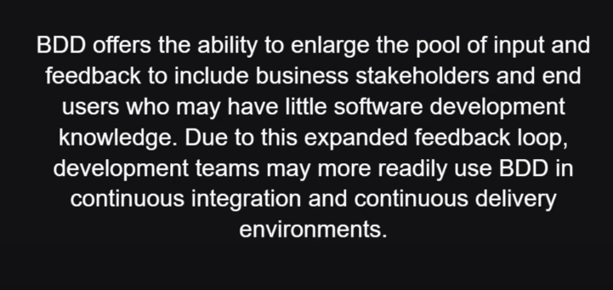 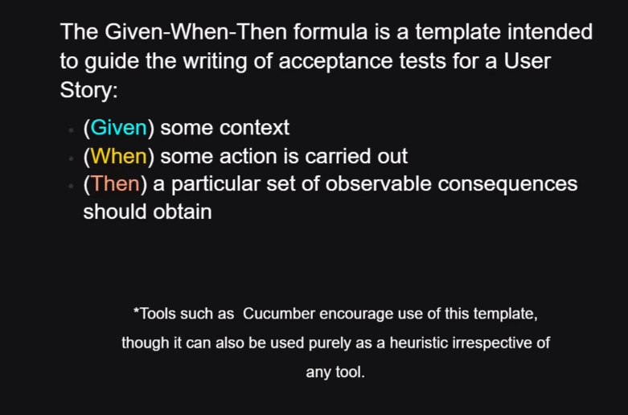 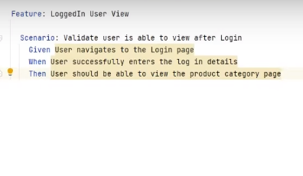 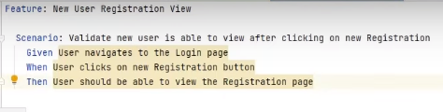   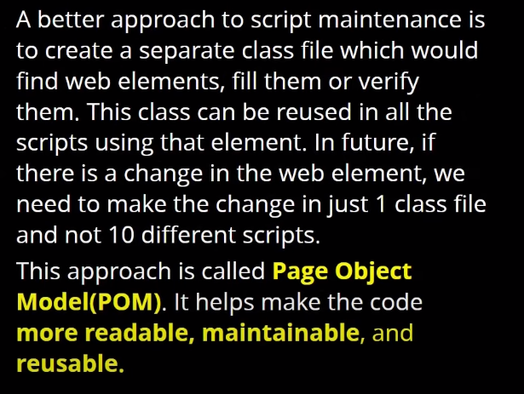 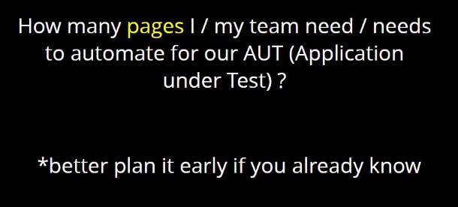 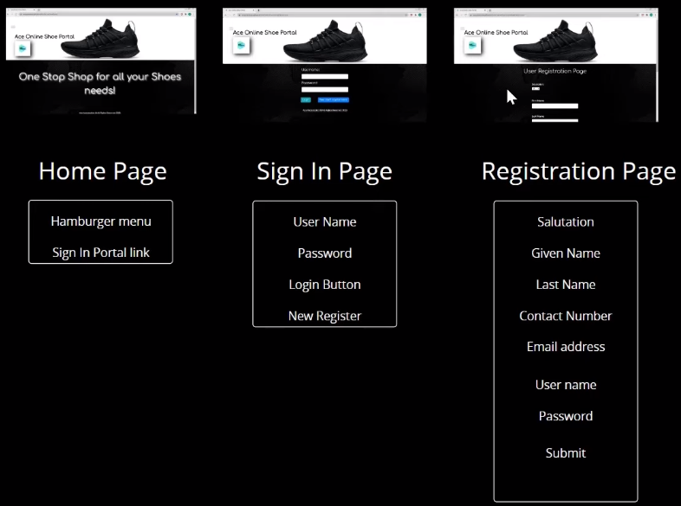 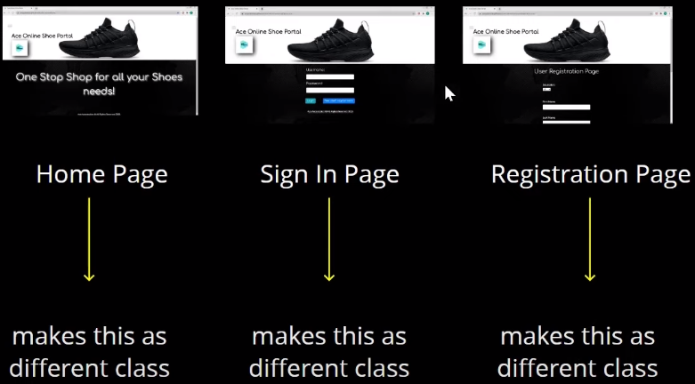 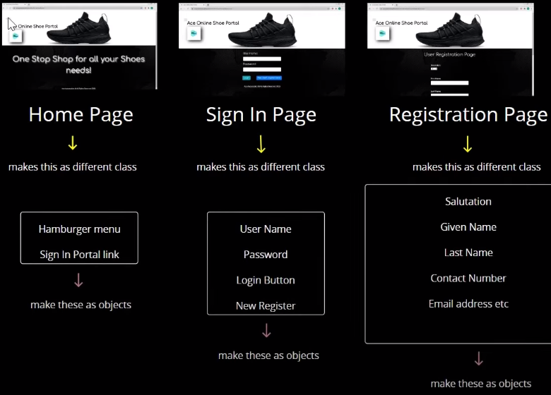 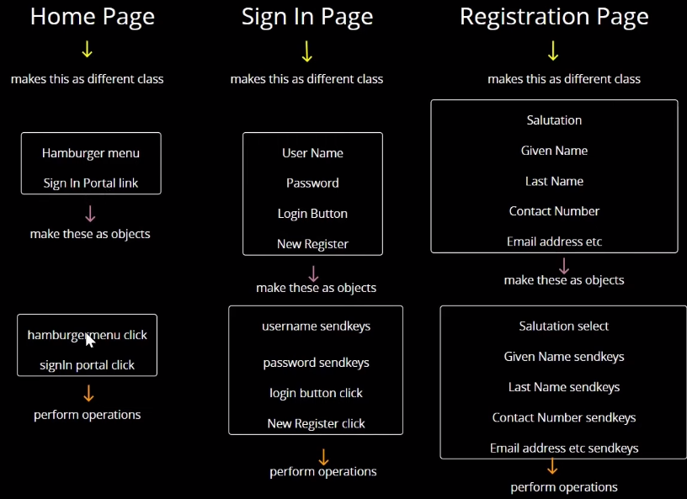 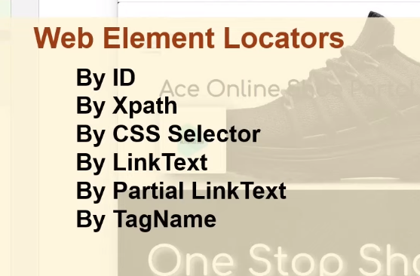 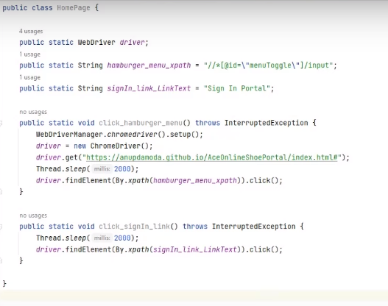 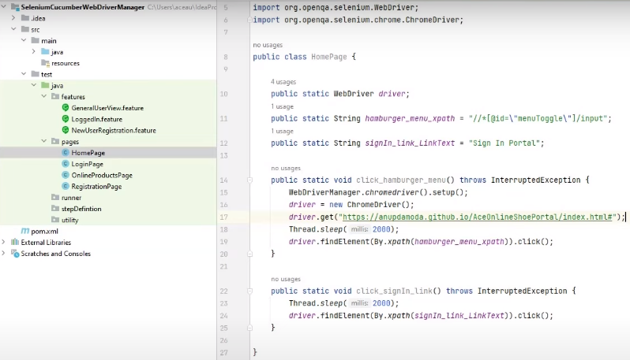 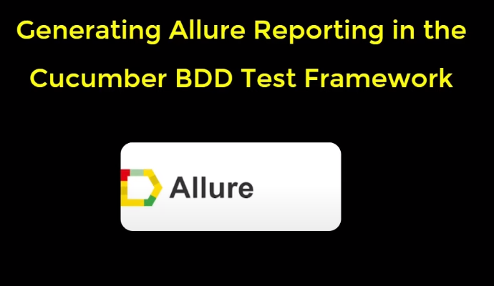 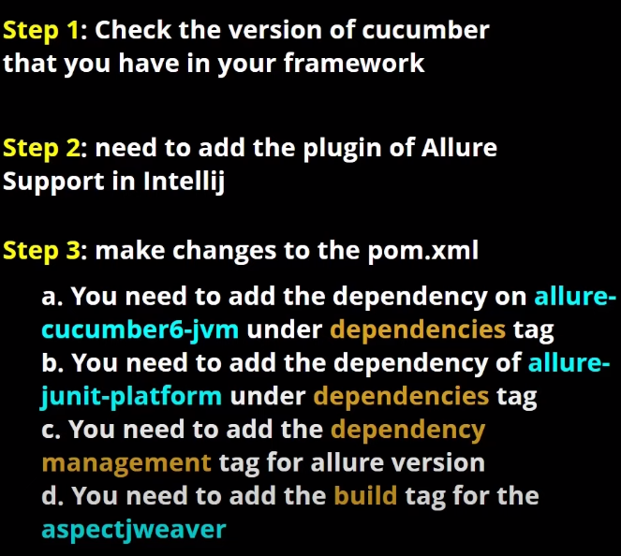 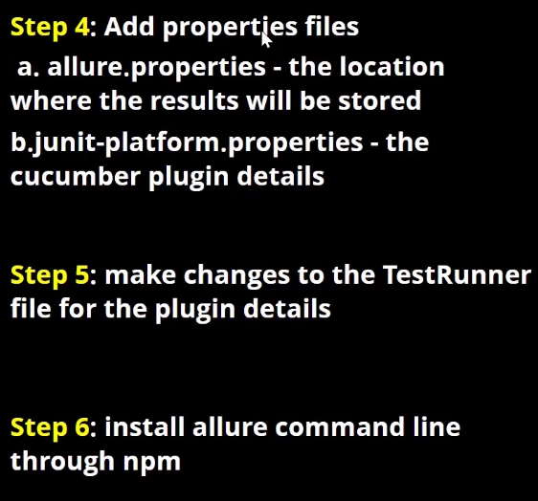 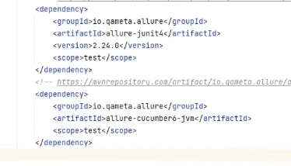 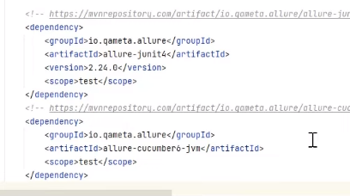 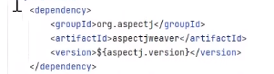 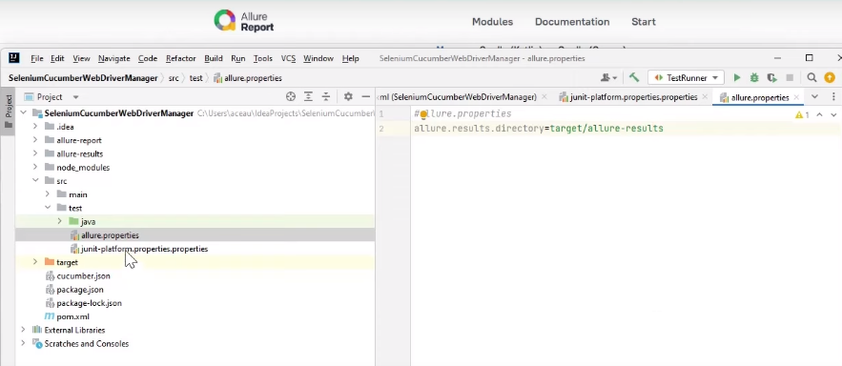 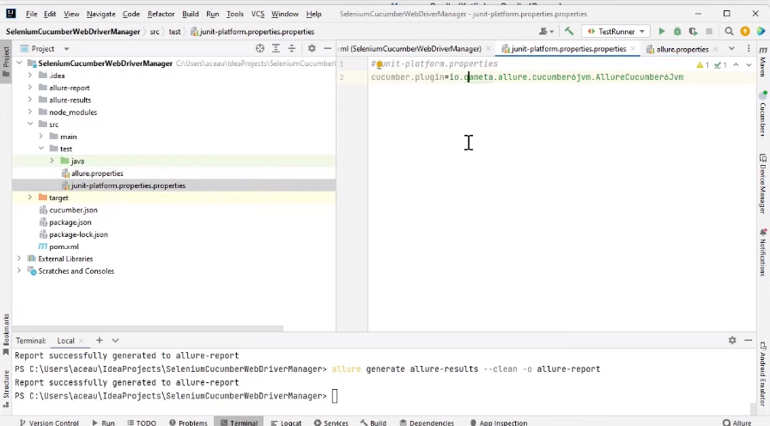 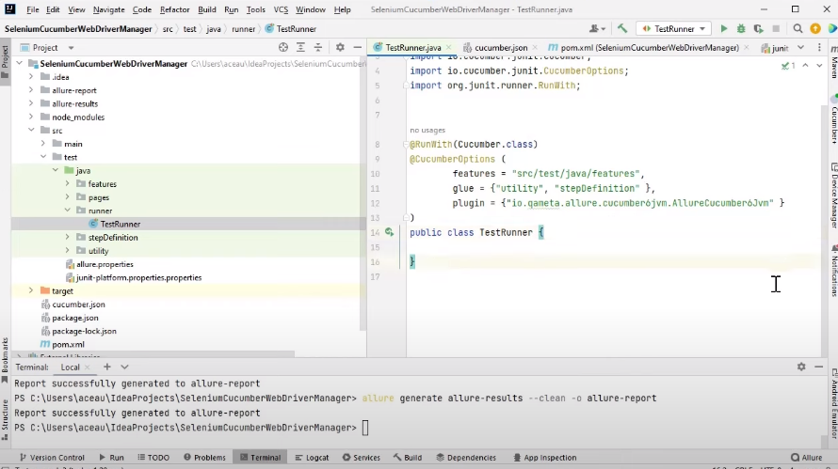

**IMPLICIT WAIT AND EXPLICIT WAIT**

Implicit wait and explicit wait is what they generally call synchronization in selenium. Because synchronization word came into the picture when qtp was there in the market, so that time they were having synchronization waits after that selenium adopted the same concept that how to put synchronization.

What synchronization even mean in selenium? It is the sync between selenium scripts, the selenium execution speed plus your web application speed. Your web application is coming, your pages are getting loaded after few seonds or maybe immediately or maybe it’s taking some time but selenium is not going to wait for that. Selenium will try to interect with those elements immediately but your speed is maybe slow or maybe slow network is there or your pages are very heavy, there are a lot of AJAX components are there or a lot of images are there. In that case, pages are taking some time to load or elements are taking some time to display on the UI in that case, we have to tell selenium, boss please, wait for some time and then click on it or enter a work on text box and then perform some action. In that case, synchronization is very very important and selenium does not provide by default synchronization. Selenium provides synchronizatiion in the form of implicitly wait and explicitly wait. We have different tools like protractor or cypress, these tools by default provide synchronization internally, But when you talk about selenium in Java, we have to implicitly or explicitly, we have to provide the synchronization. One type of synchronization, we have already seen page load time out. Page time out is for the web page loading.

You might be ask what do you mean by synchronization, how will you handle the timeouts? How will you handle synchronization concepts in selenium? They are talking about implicit wait, explicit wait only.

Below example code for page load timeouts. It means please, at least wait for 20 seconds maximum, make sure that the page is fully loaded or not then perform some action. Atleast give some 20 seconds. This is one of the dynamic wait. All the waits, either implicit wait, explicit wait or page load time out all these are dynamic waits. What do we mean by dynamic wait? It means if the page is loaded 2 seconds, the rest of the 18 seconds will be ignored. It is not going to wait for 20 seconds. Time dot sleep for 20 seconds is static wait.

Implicit wait is a global wait which is applicable for all the elements for which the driver is interacing.



Example of implicit wait. It is a global wait applicable to all the elements in a script.

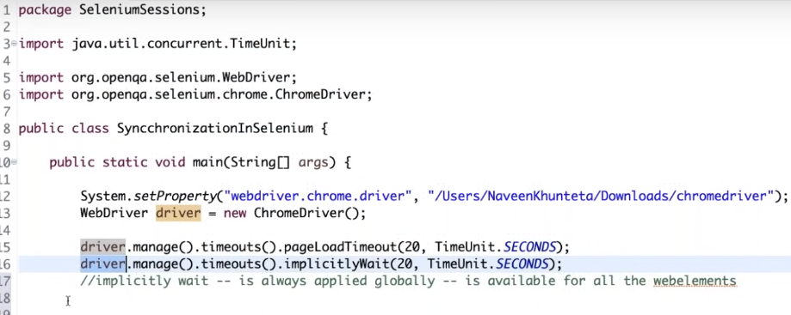

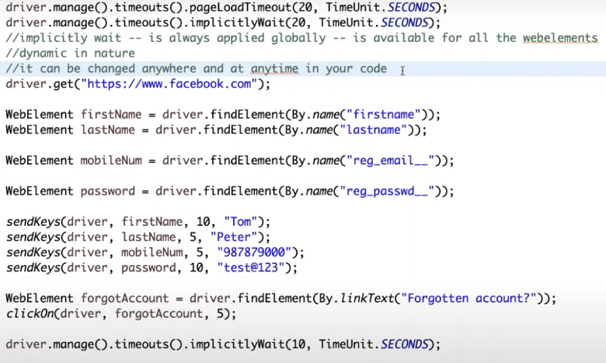

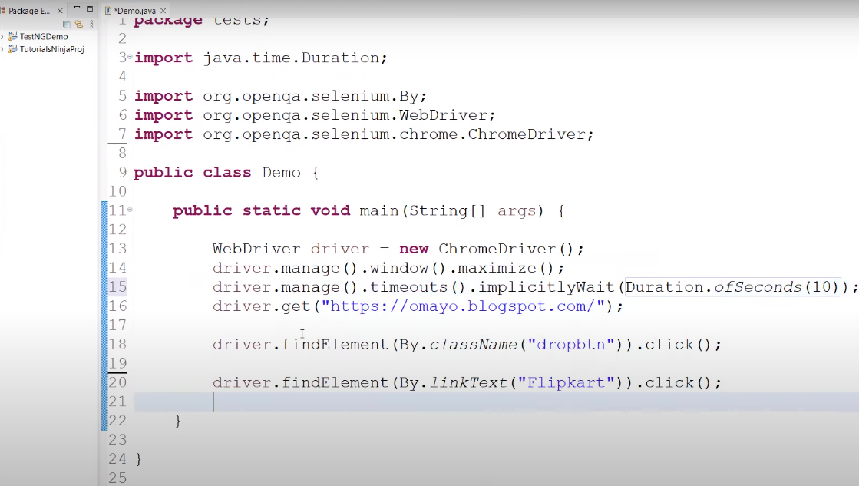

Explicit wait is not a global wait, it is an web element specific wait e.g.

We don’t have any keyword or method for explicit wait. For explicit wait is always provided by webdriver wait. So webdriver wait is actually is an explicit wait.

So we have to create the ovject of new webdriver wait and creating the object of webdriver wait class in which

